**WORK INSTRUCTIONS FOR_EMERGENCY POWER FAILURE**

**Responsibility:** **Furnace In charge/ Shift Superintend**

Criteria: Safe Shutdown & Start-up of Blast Furnace.

Identified Hazards:

1. Fall of person
2. BF Gas poisoning
3. Contact with hot metal/slag
4. Contact with hot water
5. Mech-impact
6. Fire

Significant Aspect:

1. Wastage of water
2. Leakage of BFG

### GEL/NPP power failure with Auto Blower on Cat DG ON

**Responsibility: Shift Incharge / Furnace Incharge**

Ensure auto blower starting logics are always maintained healthy, refer and follow VL/IMS/PID1/PROD/WI/09

1. In case of power failure, emergency lighting will immediately turns on at critical areas of the blast furnace. All personal working in Cast house & PCM area have to be evacuated & gather at the assembly point for further instructions. Emergency lights placed at various locations has to be used incase power failure is during dark hours. Additionally Torches have been provided to all SS & control room person.
2. During power failure water supply to all cooling members will resume immediately by gravity from overhead tanks. “Power fail to open” actuator valve at Cast house and Bustle area will open immediately whenever there is power interruption.

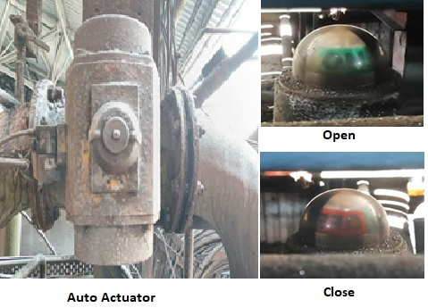

1. Manual butterfly valve also may be opened irrespective of auto actuator operation

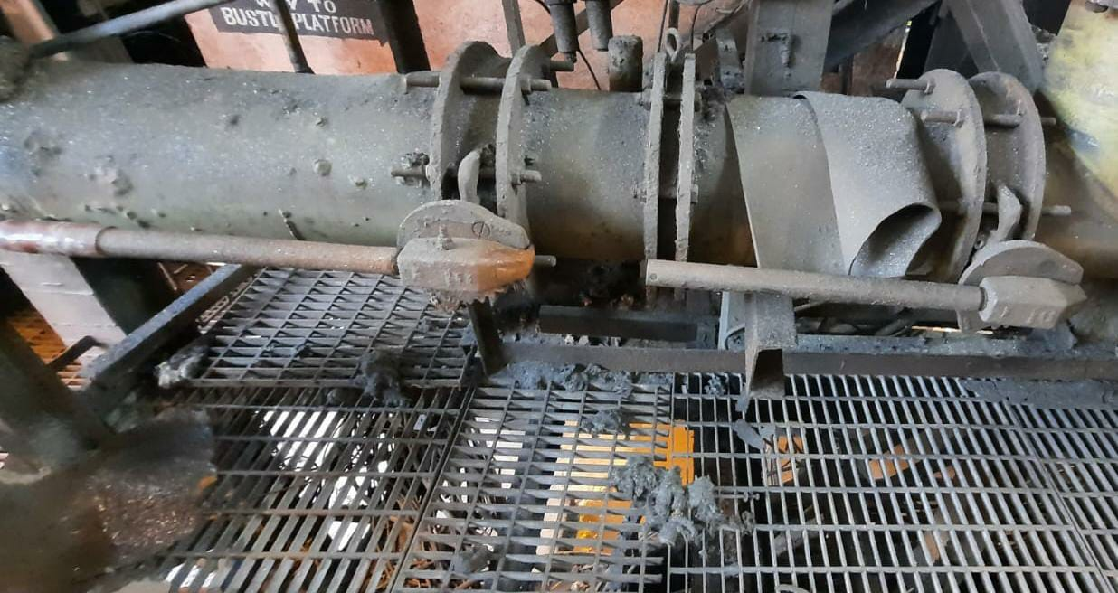 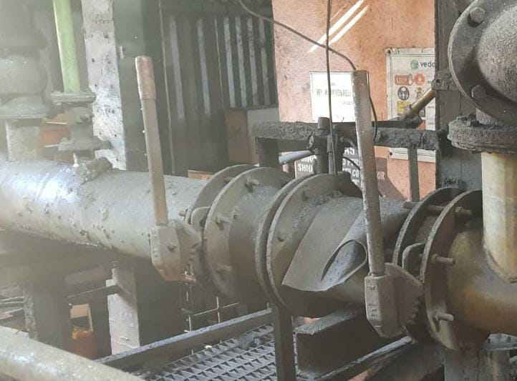

**close**

**Open**

# Please ensure that the following valves are in open position at 27 mtrs area.

1. After power failure check whether Auto blower is working and bypass tripped blowers.
2. Also check whether return water pump and cooling tower pump which are in stand-by have started.
3. Stop cooling water for upper stack after ensuring stack temps are in the range of 600- 800DegC from HMI. Upper stack can go without cooling for max 2-3 hrs.
4. Reduce the water in shell cooling & cooling plates. & ensure pressure (1.4 kg/cm2) in tuyere. Open the cast and make the furnace dry. In case of delay in starting the blowers on TG /DG, take shutdown of furnace after draining.
5. Open the bleeders if there is no clearance for GCS pumps, water seal gas line.
6. If the stove combustion air fan has tripped, get electrical clearance to start the same on DG`s.
7. After electrical clearance start the blower and increase wind to full after normalizing the cooling system.
8. If there is any delay in starting the cooling water pumps, fire hydrant water to be opened for hot blast valve cooling.

##### GEL/NPP failure with failure to start auto blower

**Responsibility: Shift Incharge /Furnace Incharge**

1. In case of power failure, emergency lighting will immediately turns on at critical areas of the blast furnace.
2. During power failure water supply to all cooling members will resume immediately by gravity from overhead tanks. “Power fail to open” actuator valve at Cast house and Bustle area will open immediately whenever there is power interruption.



1. Manual butterfly valve also may be opened irrespective of auto actuator operation.

 

**close**

**Open**

Please ensure that the incoming valves are in open position.

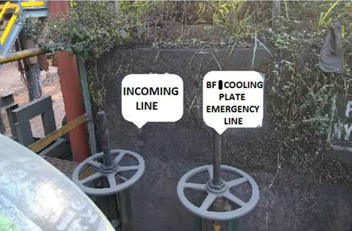

1. Open both bleeder valves and open snort valves gradually.
2. Reduce the water in shell cooling & cooling plates. & Ensure pressure (1.4 kg/cm2) in tuyere.
3. Shutdown the furnace as per the procedure (VL/IMS/PID1/PROD/WI/06A for BF1 and 6B for BF2).
4. Open peephole flanges and inspect all blowpipes for slag entry. Close the furnace isolation valves and open coffee pot valve. If the furnace was full of metal and slag do not back draft the furnace, try to open the cast if possible (**DO NOT OPEN COFFEE POT VALVE)**
5. Water seal all gas lines.
6. Water seal the gas holder also. Flarestack valve should be opened fully.
7. Contact electrical and immediately start one return water in bf2 & transfer & cooling tower pump in bf1.
8. If startup is delayed and no slag has entered blowpipes plug all tuyeres with clay. If slag has entered tuyeres clean all blowpipes and plug with clay.
9. Give steam to uptakes before startup. Follow startup procedure for starting the furnace. VL/IMS/PID1/PROD/WI/06C for BF1 and 06D for BF2
10. Ensure that the emergency lamp is glowing
11. Alert the personnel moving in the cast house for slag/metal entry into the blow pipe if the furnace is due for tapping.
12. Move carefully in the shop floor during nighttime (darkness)
13. Check all gas line /drip pots for gas leakage and arrest the same by filling water immediately.

# Instructions when the furnace top catches fire:

1. In case any fire is noticed at furnace top, immediately open the additional water sprays provided for hydraulic cylinders & hose pipes.
2. Inform mech. to check & monitor the hydro pack oil level of furnace top devices.
3. Do not allow any body to go on furnace top without complete shutdown of the furnace.
4. Take shutdown for furnace top inspection if the fire persists.

**3) EMERGENCY SHUTDOWN IN CASE OF WATER FAILURE:-**

***RESPONSIBILITY: Shift Superintendent /Furnace Incharge***

1. Open the cast immediately and make the furnace dry and take shutdown as per procedures VL/IMS/PID1/PROD/WI/06A and 06B for BF1 and BF2 respectively.
2. Inspect all copper members for burning and change if required.
3. Inspect and find out the reason for water failure:-
4. In case of pipeline rupture changeover to the standby line
5. In case of cooling tower water pressure level low, pump saline water by opening additional valves in the cooling tower or water make-up valve of overhead tank to be opened in the return water tank.
6. In case of main line water failure, Open Fire hydrant water in Tuyere and tuyere cooler.
7. If replenishment of emergency water sources is not possible and all reserve water exhausts, then all concerned personals to be evacuated to designated assembly points.
8. **Cooling tower pump failure:-**
9. During cooling tower pump failure water supply to all cooling members will resume immediately by gravity from overhead tanks. “Power fail to open” actuator valve at Cast house and Bustle area will open immediately whenever there is cooling tower pump failure



1. Connect the shell cooling to overhead tank line by opening the manual butterfly valve irrespective of whether the auto make up valve is open or not for BF1 and BF2.

 

**close**

**Open**

Please ensure that the incoming valves are in open condition at RM area.

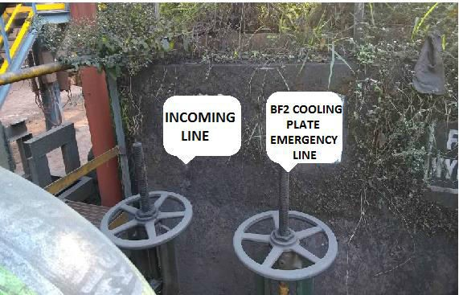

1. Reduce the wind volume to minimum, if required open the hydrant water in tuyeres or stop the water to tuyere if the water leakage in tuyeres & open the cast and make the furnace dry.
2. If required, take shutdown as per procedure. VL/IMS/PID1/PROD/WI/06A and 06B for BF1 and BF2 respectively.
3. After starting the cooling tower pump, close the O/H tank valve from C/H.
4. If cooling tower level goes above 1.75mts, then O/H makeup pump will start in auto.
5. If O/H makeup pump did not start in auto, start pump manually to avoid overflow of cooling tower.
6. Stop O/H makeup pump when cooling tower level goes below 1.5mts.
7. Check outlet water flow of tuyere & cooling plates.
8. All copper members are to be inspected for burning and changed, if required.
9. Inspection to be done and the reason for water failure is to be found out.

Start the furnace as per start-up procedure after restoring the proper water pressure in the header

**5. WATER LEAKAGE IN THE TUYERE/TUYERE COOLER & cooling plates:-**

***RESPONSIBILITY: Shift Superintendent /Furnace Incharge***

1. In case the water leakage is suspected through the tuyere / tuyere cooler & cooling plates, Inspect the outlet water flow of the particular tuyere/tuyere cooler & cooling plate thoroughly.
2. Measure the outlet water temperature of that particular tuyere/tuyere cooler & cooling plate with the help of thermometer.
3. If there is sudden variation in the temperature in the taphole / hearth region, prepare the furnace for shutdown after checking the temperature of taphole / hearth region in the monitor as well as in the recorder
4. Shutdown the furnace as per the procedure VL/IMS/PID1/PROD/WI/06 after making the furnace dry.
5. Reduce the water flow to the minimum of that particular cooling member, if water leakage is confirmed after inspection.
6. Replace the damaged cooling member after taking the measurement of seating for BF1 and BF2 respectively.

|  |  |  |
| --- | --- | --- |
| **Prepared By:**  Head – Production PID I | **Reviewed & Issued By:**  Management Representative | **Approved By:**  Head – Pig Iron Division |
| **Signature:** | **Signature:** | **Signature:** |
| **Date: 10.07.2023** | **Date: 10.07.2023** | **Date: 10.07.2023** |

|  |  |  |  |
| --- | --- | --- | --- |
| **Amendment Record** | | | |
| **Revision date** | **Manual Section ref. and para** | **Brief details of revision** | **New Revision No.** |
| **15.07.2022** | **Work instructions for emergency power failure** | Point 1 | **07** |